PDB
Python Debugger

supports setting (conditional) breakpoints and single stepping at the source line level, inspection of stack frames, source code listing, and evaluation of arbitrary Python code in the context of any stack frame. It also supports post-mortem debugging and can be called under program control

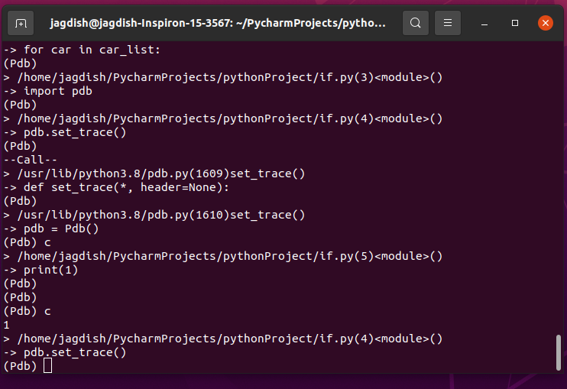

Pdb.set_trace
Enter the debugger at the calling stack frame. This is useful to hard-code a breakpoint at a given point in a program, even if the code is not otherwise being debugged. If given,header is printed to the console just before debugging begins

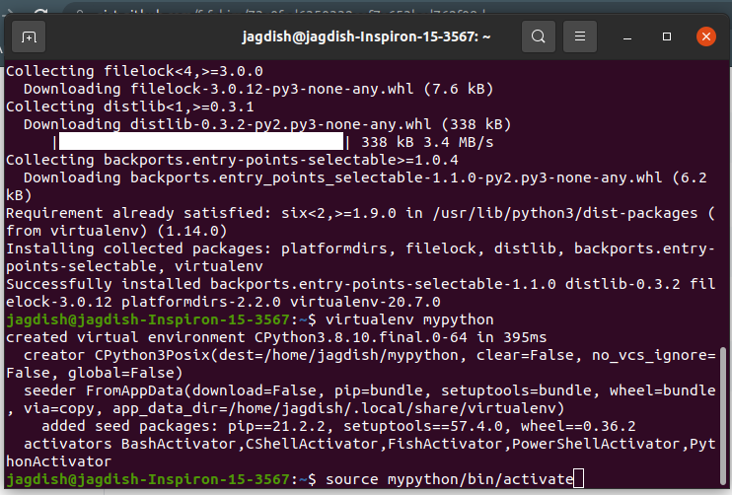

S --- Execute the current line, stop at the first possible occasion

C --- Continue execution, only stop when a breakpoint is encountered.

